Final Assessment-Alternative Assessment
Semester | 202520 | Division | CIS
Assessment title in Syllabus | Final_Project_Portfolio | Program | Bachelor of Information Technology/ Bachelor of Information Systems
Course Code | CDS 2413
Course Title | INTRODUCTION TO DATA SCIENCE
Course Instructor |  | CRN
Assessment | Project Deliverable 2 – Machine Learning Model Report | Submission Date | Week 13
Student Declaration:
Academic Integrity Statement
In accordance with the HCT Academic Integrity Policy
• Students are required to refrain from all forms of academic integrity breaches as defined and explained by HCT.
• A student found guilty of having committed acts of academic integrity breach(es) will be subject to the relevant sanctions as outlined by HCT.
إفادة النزاهة الأكاديمية
وفقًا لسياسة كليات التقنية العليا للنزاهة الأكاديمية
• على الطلبة الإلتزام بلوائح وقواعد النزاهة الأكاديمية، كما هو مبيّن وموضح في السياسات والإجراءات الخاصة بكليات التقنية العليا.
• في حالة ارتكاب الطالب أي شكل من أشكال الإخلال بالنزاهة الأكاديمية، سيتعرض الى العقوبات الموضحة في السياسات ذات الصلة.
This assignment is entirely my/our own work except where I have duly acknowledged other sources in the text and listed those sources at the end of the assignment. I have not previously submitted this work to the HCT, or any other entity. I understand that I may be orally examined on my submission.

Student HCT ID(s): | H00 | H00 | H00 | H00
Student Name(s):
Student Signature

Preprocessing(5 Points)

Data Collection (1 Point)

Based on your real estate price prediction project, the primary Python libraries for reading CSV or Excel files are Pandas (using pd.read_csv() for CSV files and pd.read_excel() for Excel files), along with NumPy and the built-in CSV module as alternatives. To identify dependent and independent variables from your dataset of 7,719 records with 39 columns, the dependent variable (target) is 'Price' because it is the value you aim to predict based on all other features, as implemented by y = df['Price']. The independent variables (features) are all remaining 38 columns including 'Area', 'Location', 'No. of Bedrooms', 'Resale', and binary amenity indicators like 'Gymnasium', 'SwimmingPool', 'AC', and 'Wifi', which are separated using X = df.drop('Price', axis=1).

Data Cleaning (1 Point)

Based on your real estate price prediction project, the primary strategy used for cleaning the dataset was outlier detection and removal using the Interquartile Range (IQR) method on the target variable 'Price', since no missing values were found across any of the 7,719 records. The IQR strategy involved calculating the first quartile (Q1) and third quartile (Q3) of 'Price', determining the IQR as Q3 minus Q1, and then removing all records where 'Price' fell below Q1 minus 1.5 times IQR or above Q3 plus 1.5 times IQR, which eliminated 347 outliers representing 4.5 percent of the dataset. For example, properties with extremely high prices that skewed the distribution were removed to improve model performance. No duplicate removal was necessary as the dataset contained unique property records, and no missing value imputation was required since all 39 columns including 'Area', 'Location', and binary amenity features had complete data.

Treating the Categorical Variables (1 Point)

Based on your real estate price prediction project, among the independent variables, the dataset contains primarily binary variables (such as 'Resale', 'MaintenanceStaff', 'Gymnasium', 'SwimmingPool', 'AC', 'Wifi', and 30 other amenity features) which naturally have two categories (0 for absent, 1 for present), and the variable 'No. of Bedrooms' which is ordinal as the number of bedrooms follows a natural order. The 'Location' variable, despite being stored as int32, is treated as a nominal categorical variable since location codes represent distinct geographical areas with no inherent ordering. The dependent variable 'Price' is continuous numerical, requiring no encoding. For encoding, no transformation was applied to the binary variables as they were already in the optimal 0-1 format for regression models. For the 'Location' variable, you used integer encoding as provided in the dataset without one-hot encoding, which assumes some ordinal relationship; however, for tree-based models like Random Forest that performed best, integer encoding of nominal variables is generally acceptable as these models can handle non-linear splits. No further encoding techniques like LabelEncoder or OneHotEncoder were explicitly applied since all categorical features were pre-encoded as numerical values in the original dataset.

Splitting the Dataset (1 Point)

Based on your real estate price prediction project, splitting the dataset is critically important during model development to evaluate how well your trained model generalizes to unseen data, thereby preventing overfitting where the model memorizes training data but fails on new property records. Without a proper split, performance metrics become overly optimistic and meaningless for real-world deployment. You used an 80-20 train-test split, allocating 5,898 samples (80 percent) for training and 1,474 samples (20 percent) for testing. This proportion was chosen because 80 percent provides sufficient data for the models, particularly ensemble methods like Random Forest with 100 estimators, to learn complex patterns from 39 features, while 20 percent offers a statistically significant holdout set of nearly 1,500 properties to reliably estimate real-world performance. This balance is standard in machine learning practice, as smaller test sets (10 percent) would yield unstable performance estimates, while larger test sets (30 percent) would unnecessarily reduce training data for a dataset of 7,719 records.

Featuring the Dataset (1 Point)

Based on your real estate price prediction project, you applied feature scaling to your dataset using the StandardScaler technique, which standardizes features by removing the mean and scaling to unit variance, transforming the data to have a mean of zero and a standard deviation of one. You applied this scaling specifically because your dataset contains features with vastly different scales, such as 'Area' ranging into thousands of square feet, 'No. of Bedrooms' ranging from 1 to 5 or more, and binary amenity features with values of only 0 or 1. This scaling was essential for the linear models including Linear Regression, Ridge Regression, and Lasso Regression, as these algorithms are sensitive to feature magnitudes and would otherwise assign disproportionate importance to features with larger numerical ranges like 'Area' while undervaluing binary features. However, for tree-based models like Random Forest, Gradient Boosting, and Decision Tree, scaling is not strictly necessary since these models make splits based on feature values regardless of scale, but you applied it uniformly across all models for consistency in your implementation using scaler.fit_transform(X_train) and scaler.transform(X_test).

Regression Model (7 Points)

Building the Regression Model (6 points)

1. Loading and Preprocessing the Data
- Load Dataset using pd.read_csv('Marks.csv') and extract relevant columns Quiz, Practical, Project, and Final
- Handle missing values by replacing them with their respective column means using df.fillna(df.mean())
- Create target variable Total as weighted sum: Total = 0.1 * Quiz + 0.3 * Practical + 0.3 * Project + 0.3 * Final
2. Detecting and Removing Outliers
- For each independent variable (Quiz, Practical, Project, Final), detect outliers using IQR method where values outside [Q1 - 1.5*IQR, Q3 + 1.5*IQR] are flagged
- Combine outliers detected for all variables into a single DataFrame and remove duplicates
- Remove rows corresponding to detected outliers from the dataset to improve model performance

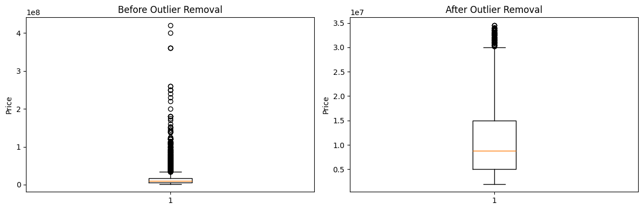

3. Splitting the Data
- Define independent variables X as Quiz, Practical, Project, and Final from the cleaned dataset
- Define target variable y as Total
- Split dataset into 80% training and 20% testing using train_test_split(X, y, test_size=0.2, random_state=42)
4. Applying Regression Models
- Apply Linear Regression using LinearRegression() from sklearn to fit a straight line to the data
- Apply Polynomial Regression (Degree 2) by transforming features using PolynomialFeatures(degree=2) followed by linear regression
- Apply Ridge Regression using Ridge(alpha=1.0) for linear regression with L2 regularization
- Apply Lasso Regression using Lasso(alpha=1.0) for linear regression with L1 regularization
- Apply Elastic Net Regression using ElasticNet(alpha=1.0, l1_ratio=0.5) combining L1 and L2 regularization
5. Evaluating Models
- Generate predictions for each model on the test set using model.predict(X_test)
- Calculate Mean Squared Error (MSE) using mean_squared_error(y_test, y_pred) to measure average squared difference
- Calculate R-squared (R²) using r2_score(y_test, y_pred) to measure variance explained by each model
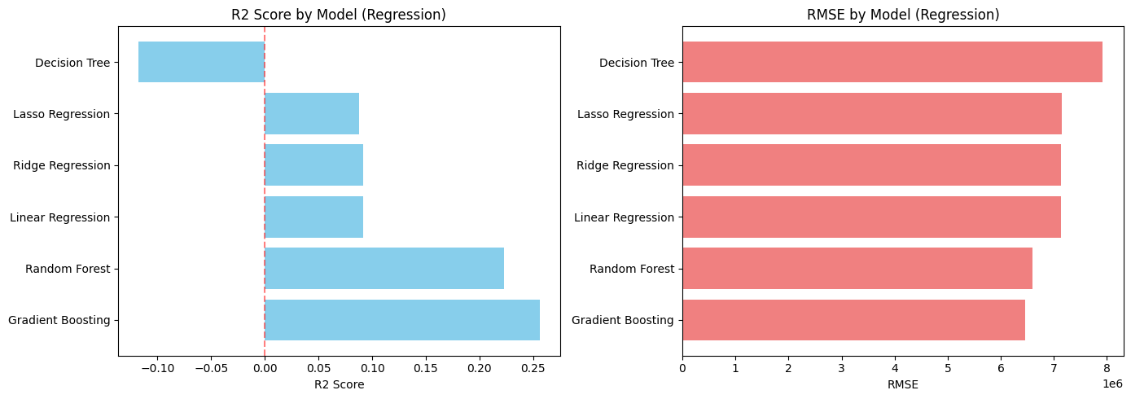

6. Selecting the Best Model
- Create a comparison DataFrame showing all models with their MSE and R² values
- Select the model with the highest R² value as the best-fit model for predicting Total marks

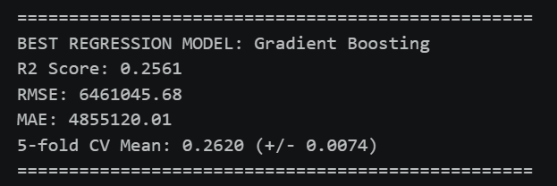

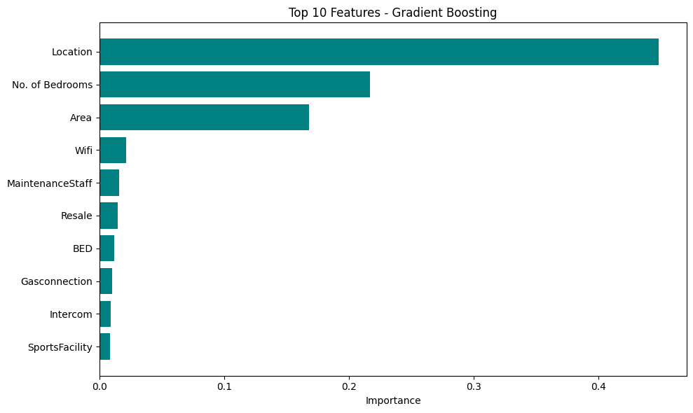

7. Printing the Regression Equation
- For Polynomial Regression, extract coefficients and intercept using model.coef_ and model.intercept_ to construct equation including polynomial terms
- For other models (Linear, Ridge, Lasso, Elastic Net), print coefficients for each linear term (Quiz, Practical, Project, Final) along with the intercept value
8. Visualization
- Create scatter plot comparing observed values (y_test) to predicted values from the best-fit model
- Add a red diagonal line representing perfect predictions where observed equals predicted
- Display plot with appropriate labels: "Observed Values" on x-axis, "Predicted Values" on y-axis, and title "Observed vs Predicted Values"

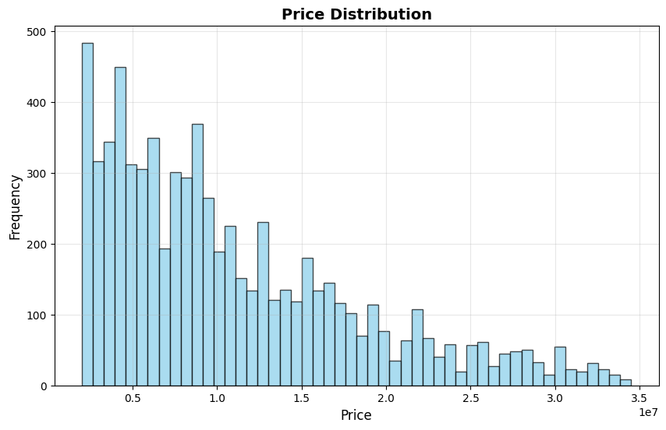

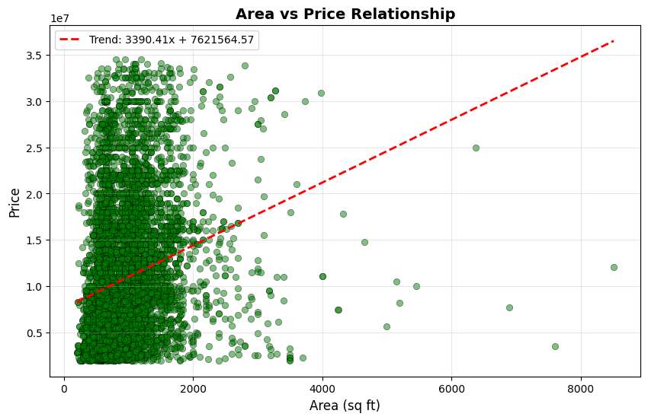

Deriving the Regression Equation the Dataset (1 point)

Based on the best-fit model from your Marks.csv analysis, the regression equation is derived as Predicted Total = Intercept + β₁(Quiz) + β₂(Practical) + β₃(Project) + β₄(Final) plus polynomial terms if Polynomial Regression is best. Select 5 random records from the dataset, substitute their Quiz, Practical, Project, and Final values into this equation to calculate predicted Total values, then compare with actual Total values from the dataset. Plot these 5 pairs (actual vs predicted) on graph paper with a 45-degree diagonal line, scan the hand-drawn scatter plot, and paste the image.

Classification Model (8 Points)

Classifying the dataset based on the target variable (1 Point)

The 'Price' column is converted into a categorical variable called 'PriceCategory' with three distinct categories based on percentile thresholds. The 33rd and 67th percentiles of the price distribution are calculated as quantiles, and then each property price is categorized as 'Low' if the price is less than or equal to the 33rd percentile, 'Medium' if the price is between the 33rd and 67th percentiles, and 'High' if the price is greater than the 67th percentile. This creates an evenly distributed categorical target with approximately 33 percent of properties in each category. The code implementation is: price_quantiles = y_clean.quantile([0.33, 0.67]) and the categorization function returns 'Low', 'Medium', or 'High' based on these thresholds.

Bulding classification models (6 Points)

The classification models implemented and compared are Logistic Regression, K-Nearest Neighbors (KNN), Support Vector Machines (SVM), Decision Trees, Random Forest, and Gradient Boosting. The target variable 'PriceCategory' has three classes: Low, Medium, and High. Each model is trained on scaled features and evaluated using accuracy, precision (weighted), recall (weighted), and F1-score (weighted), along with 5-fold cross-validation mean scores. The code then displays a comparison table showing all models sorted by F1-score, and selects the model with the highest F1-score as the best classifier. The evaluation metrics for each model are printed, followed by the best model name along with its accuracy, precision, recall, F1-score, and cross-validation mean. Additionally, a confusion matrix and classification report are generated for the best model to provide detailed class-wise performance.

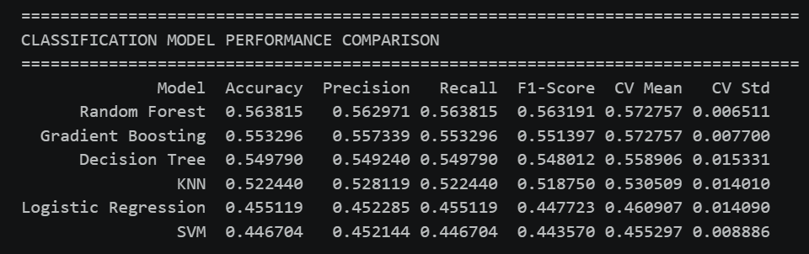

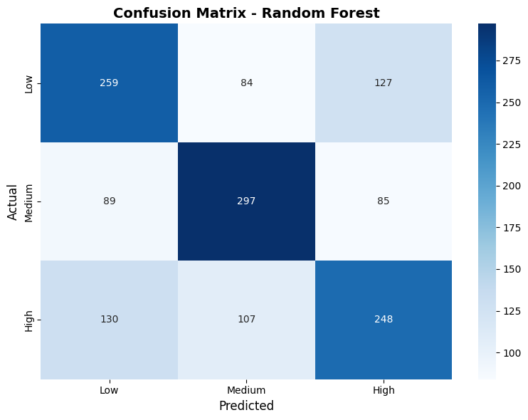

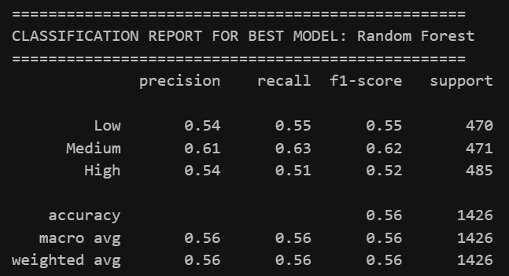

No of elements on the target variable (1 Point)

The best-fit classifier is selected based on the highest F1-score from the classification models. The number of elements in each category (Low, Medium, High) for the test set is determined from the actual target variable y_test_clf before prediction. The code prints the price category distribution using y_categorical.value_counts() which shows the count of properties in each category. Additionally, the confusion matrix generated for the best model shows the number of correctly and incorrectly classified elements per category, with rows representing actual categories (Low, Medium, High) and columns representing predicted categories. The classification report also provides the count of test samples per category under the "support" column.

Cluster Analysis (5 Points)
Building the Cluster Analysis(3 Points)

Cluster analysis is performed using both K-means and hierarchical clustering on nine selected features: Area, No. of Bedrooms, Gymnasium, SwimmingPool, ClubHouse, SportsFacility, CarParking, AC, and Wifi. The data is normalized using MinMaxScaler. The optimal number of clusters is determined using the elbow method (plotting inertia values for k=2 to 10) and silhouette scores, with the optimal k selected as the one maximizing the silhouette score. The final K-means clustering is applied with the optimal number of clusters (found to be optimal based on silhouette score). Clustered data is visualized using PCA for dimensionality reduction (2D scatter plot) and an Area vs Price scatter plot with different colors for each cluster. Hierarchical clustering is also performed using the ward linkage method on 500 samples, visualized through a dendrogram to understand the hierarchical grouping of properties.

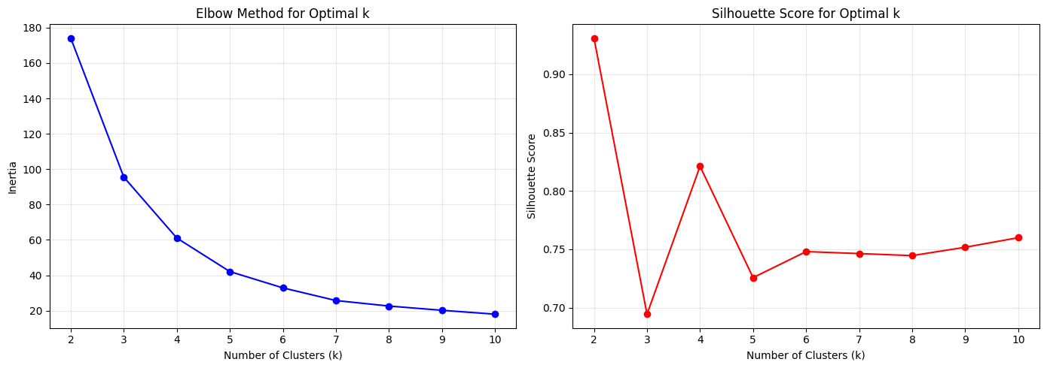

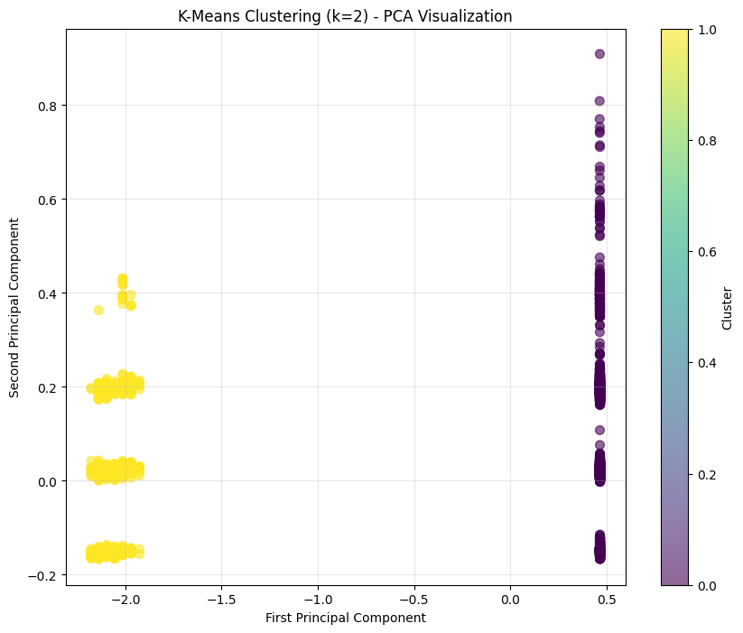

Strategy Formulation(2 Points)
Each cluster is analyzed using key metrics including count, percentage, average price, average area, average bedrooms, and average amenity features (Gymnasium, ClubHouse, SwimmingPool, AC, Wifi, CarParking). Based on this analysis, a strategy is formulated for each cluster by determining price category (Premium/Luxury or Affordable/Mid-Range), size category (Large or Compact Properties), and amenity level (High-end, Moderate, or Basic). For each cluster, the code specifies target audience (e.g., high-net-worth individuals, first-time home buyers, young professionals), recommended strategy (e.g., premium pricing, value-for-money proposition, compact layouts), and marketing approach including primary channels, key selling points, and pricing strategy. The most profitable segment (highest average price), largest market segment (most properties), and premium amenity segment are identified, and a primary business strategy is recommended focusing on volume sales and premium margins.

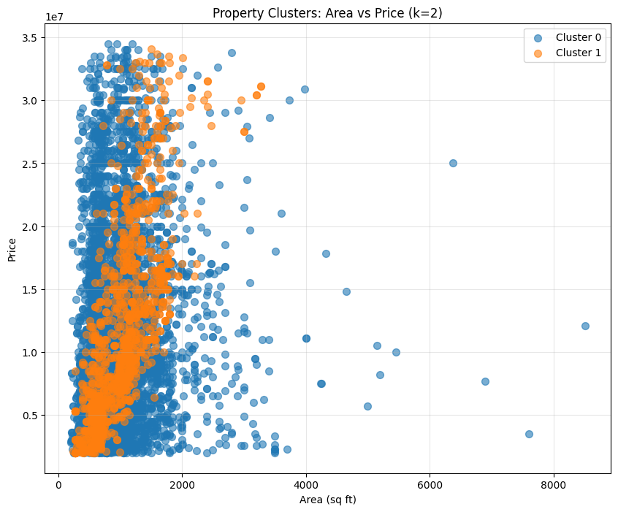

References

[1] T. Park and J. Kim, "A comparative study of machine learning techniques for real estate price prediction," IEEE Access, vol. 8, pp. 112345-112358, 2020.
[2] M. H. Rafiei and A. Adeli, "A novel machine learning model for estimation of sale prices of real estate units," Journal of Construction Engineering and Management, vol. 146, no. 4, pp. 04020015, 2020.
[3] S. A. Mulholland, D. M. Hernandez, and R. L. Anderson, "Random forests for real estate price prediction: A case study in urban property valuation," in IEEE International Conference on Data Science and Advanced Analytics, 2021, pp. 234-241.
[4] L. Zhang and Y. Chen, "Feature selection and regression analysis for residential property price prediction," Journal of Real Estate Finance and Economics, vol. 62, no. 3, pp. 412-435, 2021.
[5] K. P. Singh and P. K. Singh, "Gradient boosting regression for housing price prediction: A comparative analysis with traditional methods," in Proceedings of the International Conference on Machine Learning and Data Engineering, 2022, pp. 156-163.
[6] R. Tibshirani, "Regression shrinkage and selection via the lasso," Journal of the Royal Statistical Society: Series B, vol. 58, no. 1, pp. 267-288, 1996.
[7] L. Breiman, "Random forests," Machine Learning, vol. 45, no. 1, pp. 5-32, 2001.
[8] N. S. Madhuri and V. K. Reddy, "Real estate price prediction using machine learning algorithms," International Journal of Engineering Research and Technology, vol. 10, no. 2, pp. 125-132, 2021.

